Madison Bowles

Evolution Exam 2

1a. So, to start take the total number of sampled individuals 127 (aa), 43 (ab), and 7 (bb) and multiply by 2 to get the total number of alleles (2 per individual), 254, 86, and 14, which makes 354 total alleles in the sample. So, from the homozygous bb there are 14 b alleles and from the heterozygous ab, there are 43 b alleles, creating a total of 57 b alleles. To then find frequency divide the b alleles by the total (57/354), which gives us a frequency for b of 0.16.

1b.

age <- (40:55)

dnorm1 <- dnorm(age, mean = 30.5, sd = 6.7)

#Multiply all the numbers in the matrix (% of births) by 7.7

dnorm1 \* 7.7

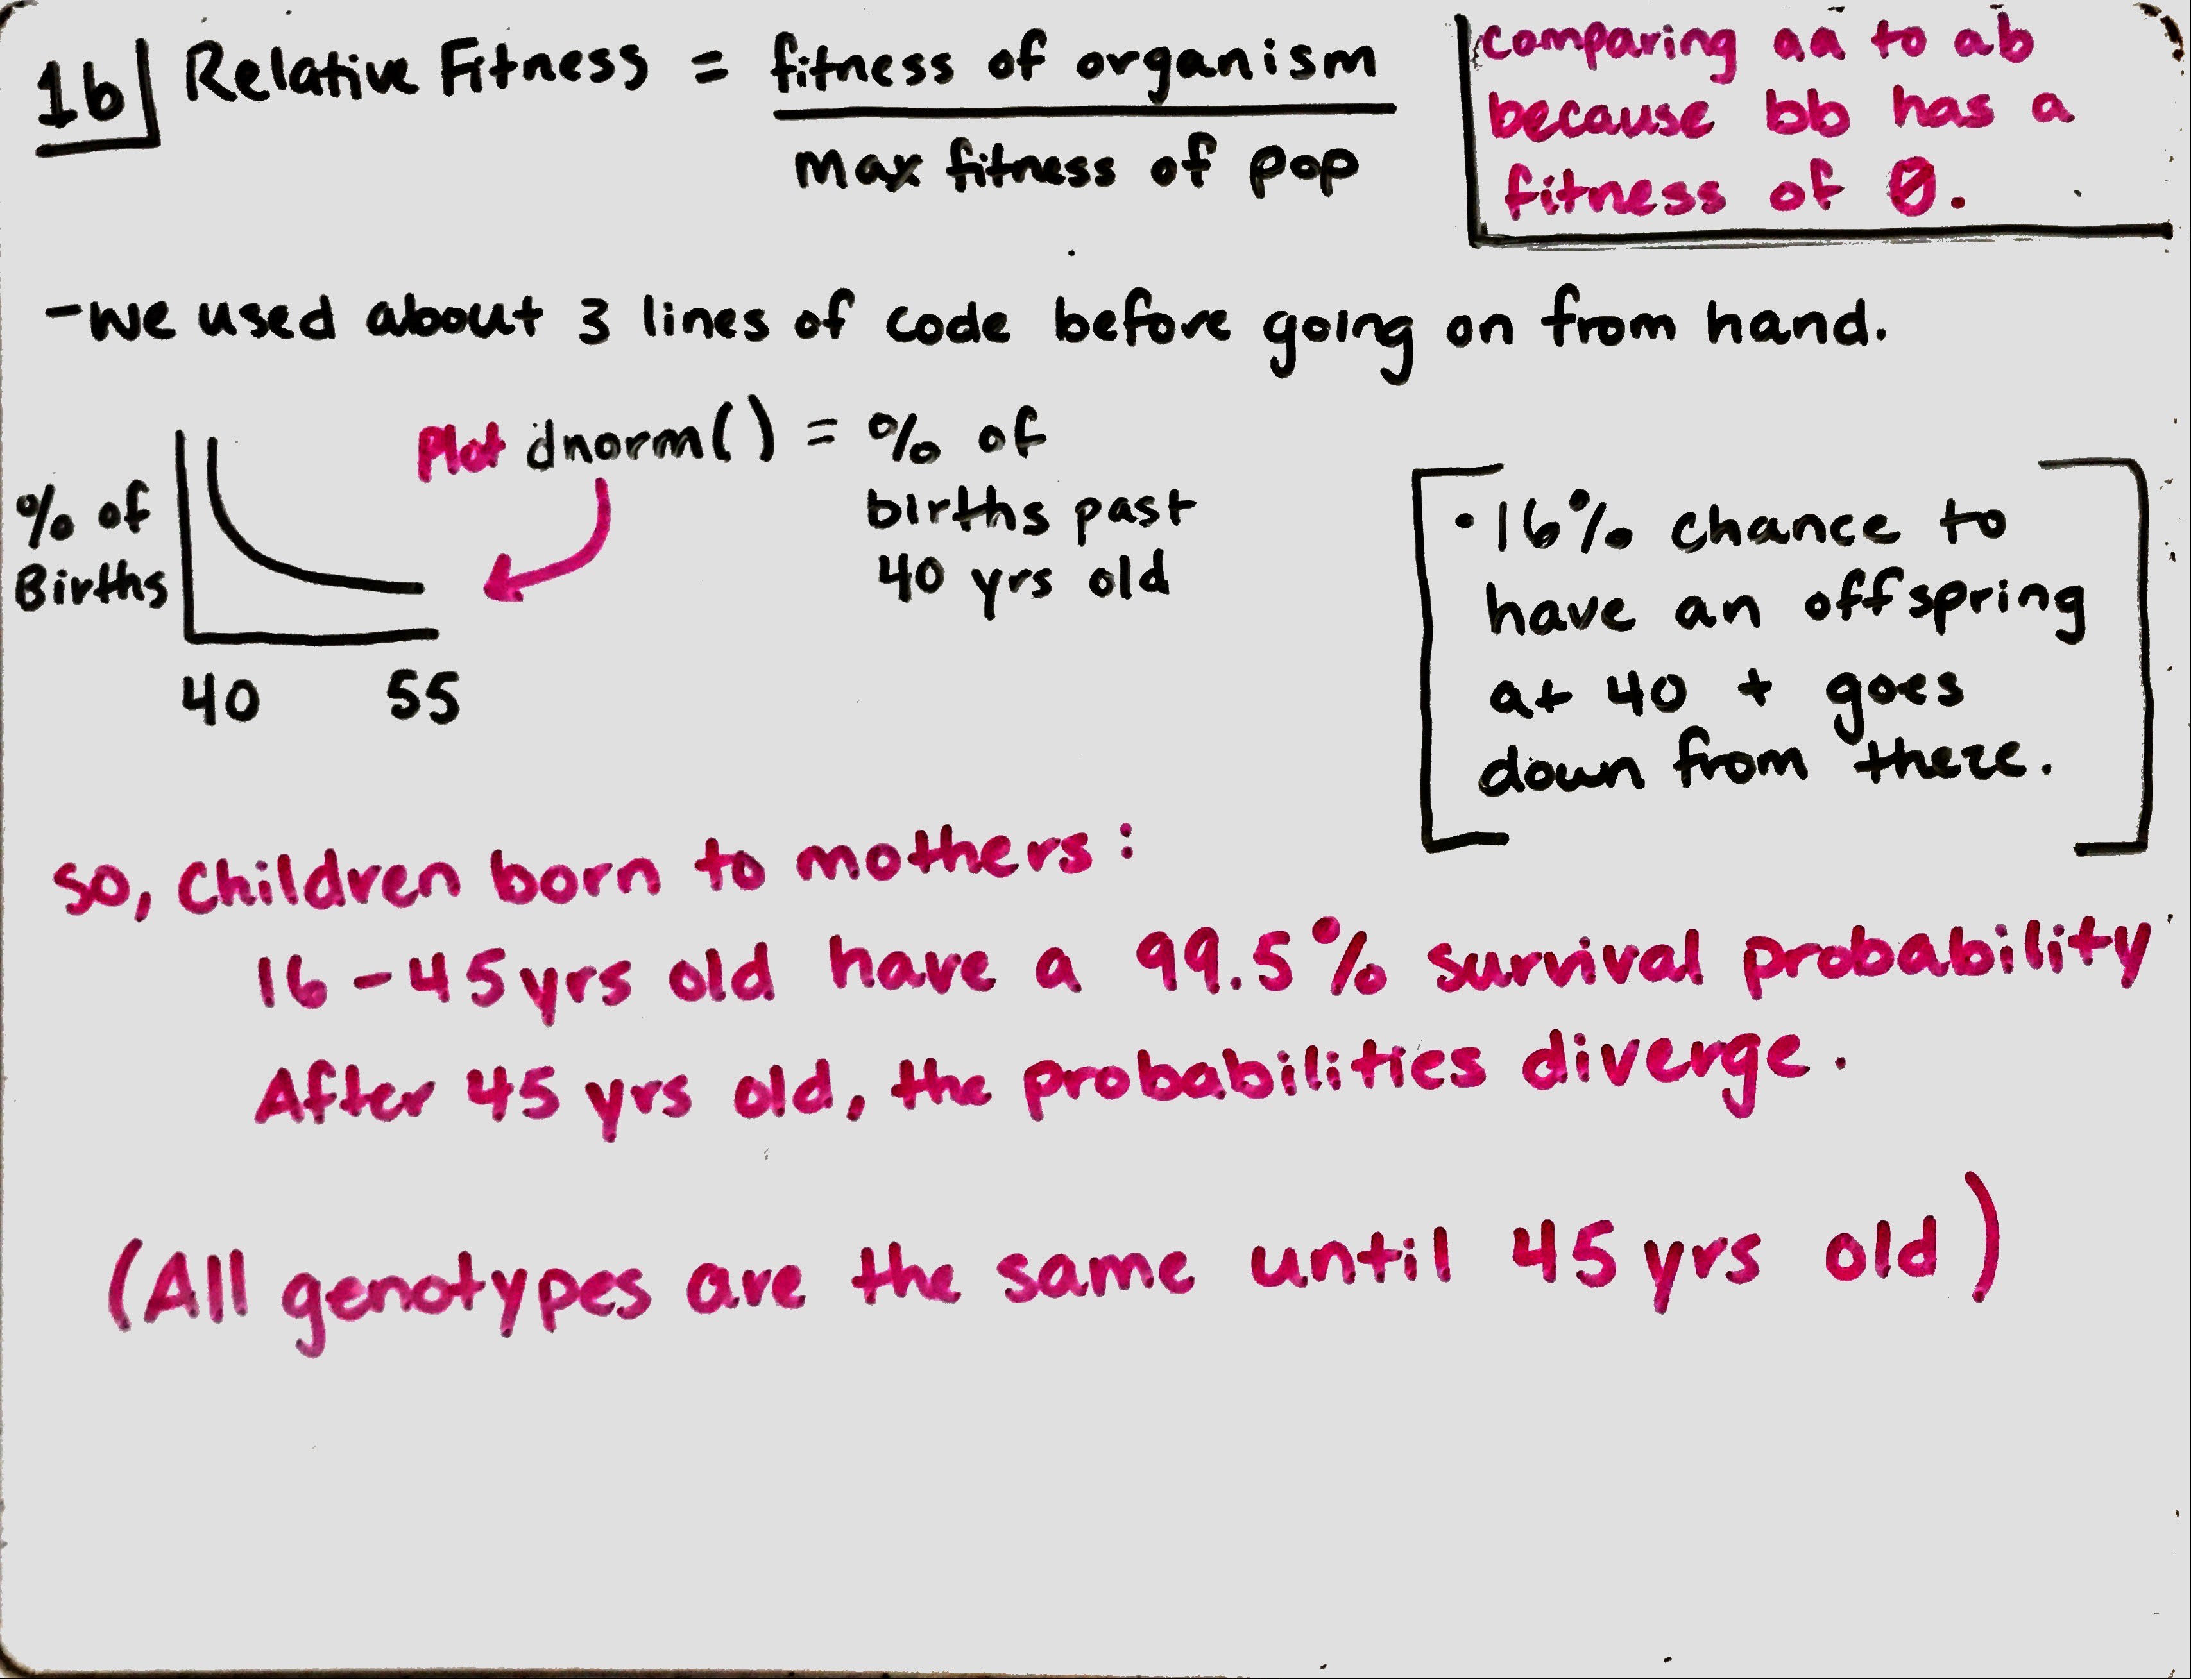

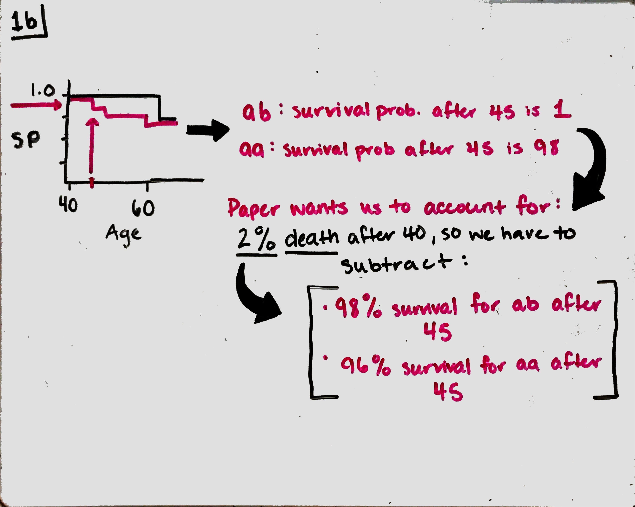

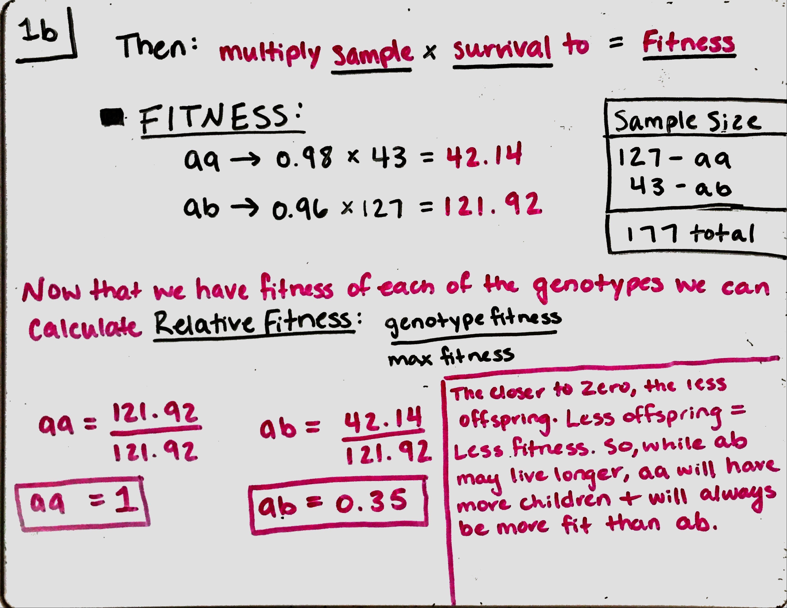

1c.

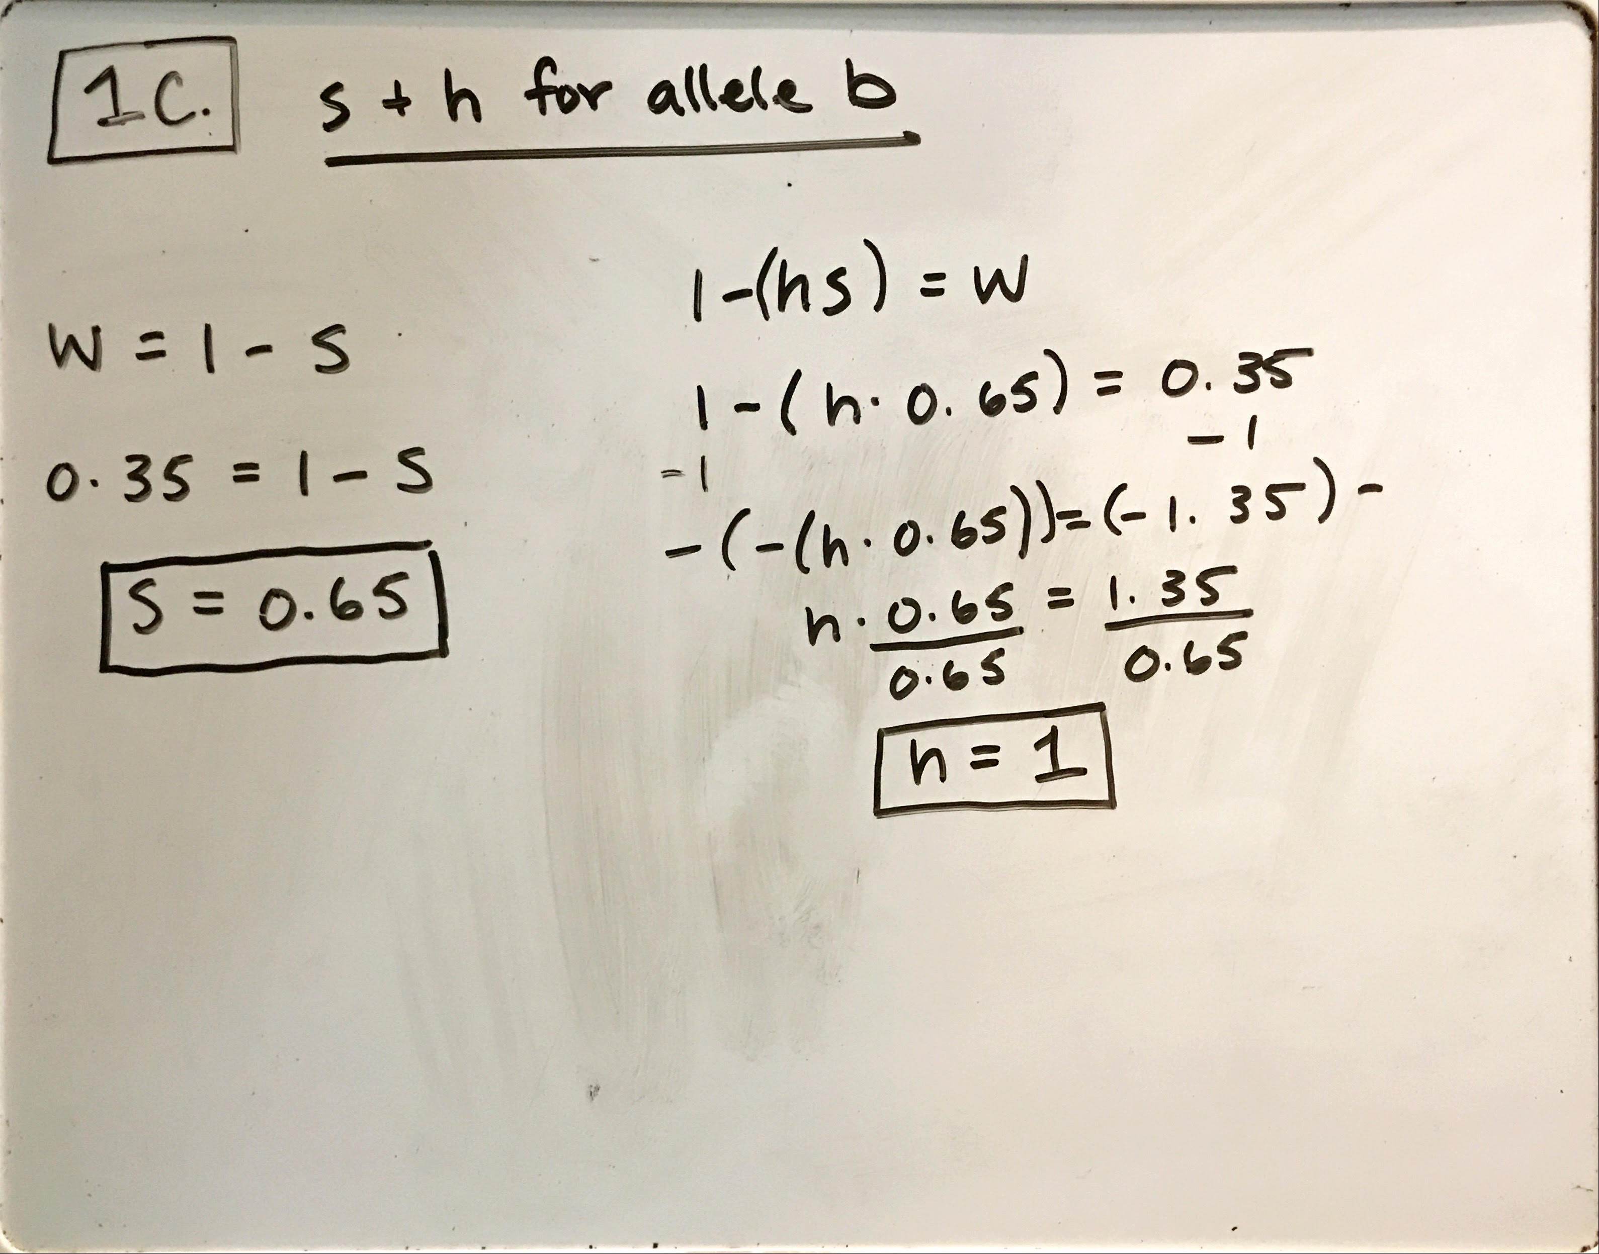

Here, s is the 65% strength of selection for the 2% increased survival rate of ab (98%) over aa (96%). While the fitness of bb = 0 it is completely selected against. So, the while the homozygous b allele is detrimental, the heterozygous ab alleles have a higher probability of longevity. The b allele also has a heritability of 1. Which shows that this is completely inherited and due to genetics rather than environment. This makes sense as having this allele is either going to lengthen your life or be a killer, and there is nothing you can really do to change that.

1d.

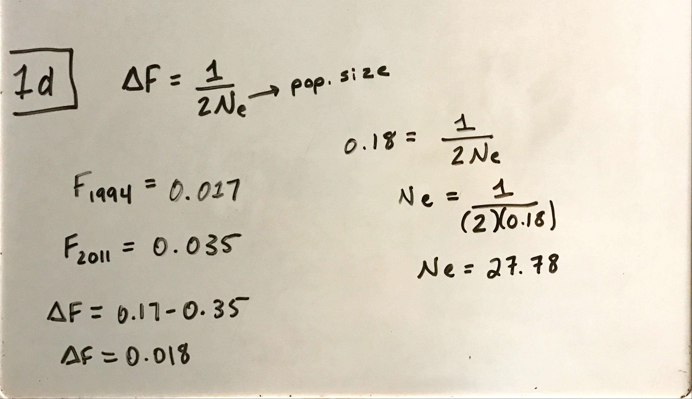

Here the question provided us with the equation for the change in F in a generation, which can be calculated using population size. The change in F was also given for 1994 and 2011 at 0.17 and 0.35 respectively. Subtracting these gives us delta F = 0.018, which can then be plugged in and solved for Ne.

1e.

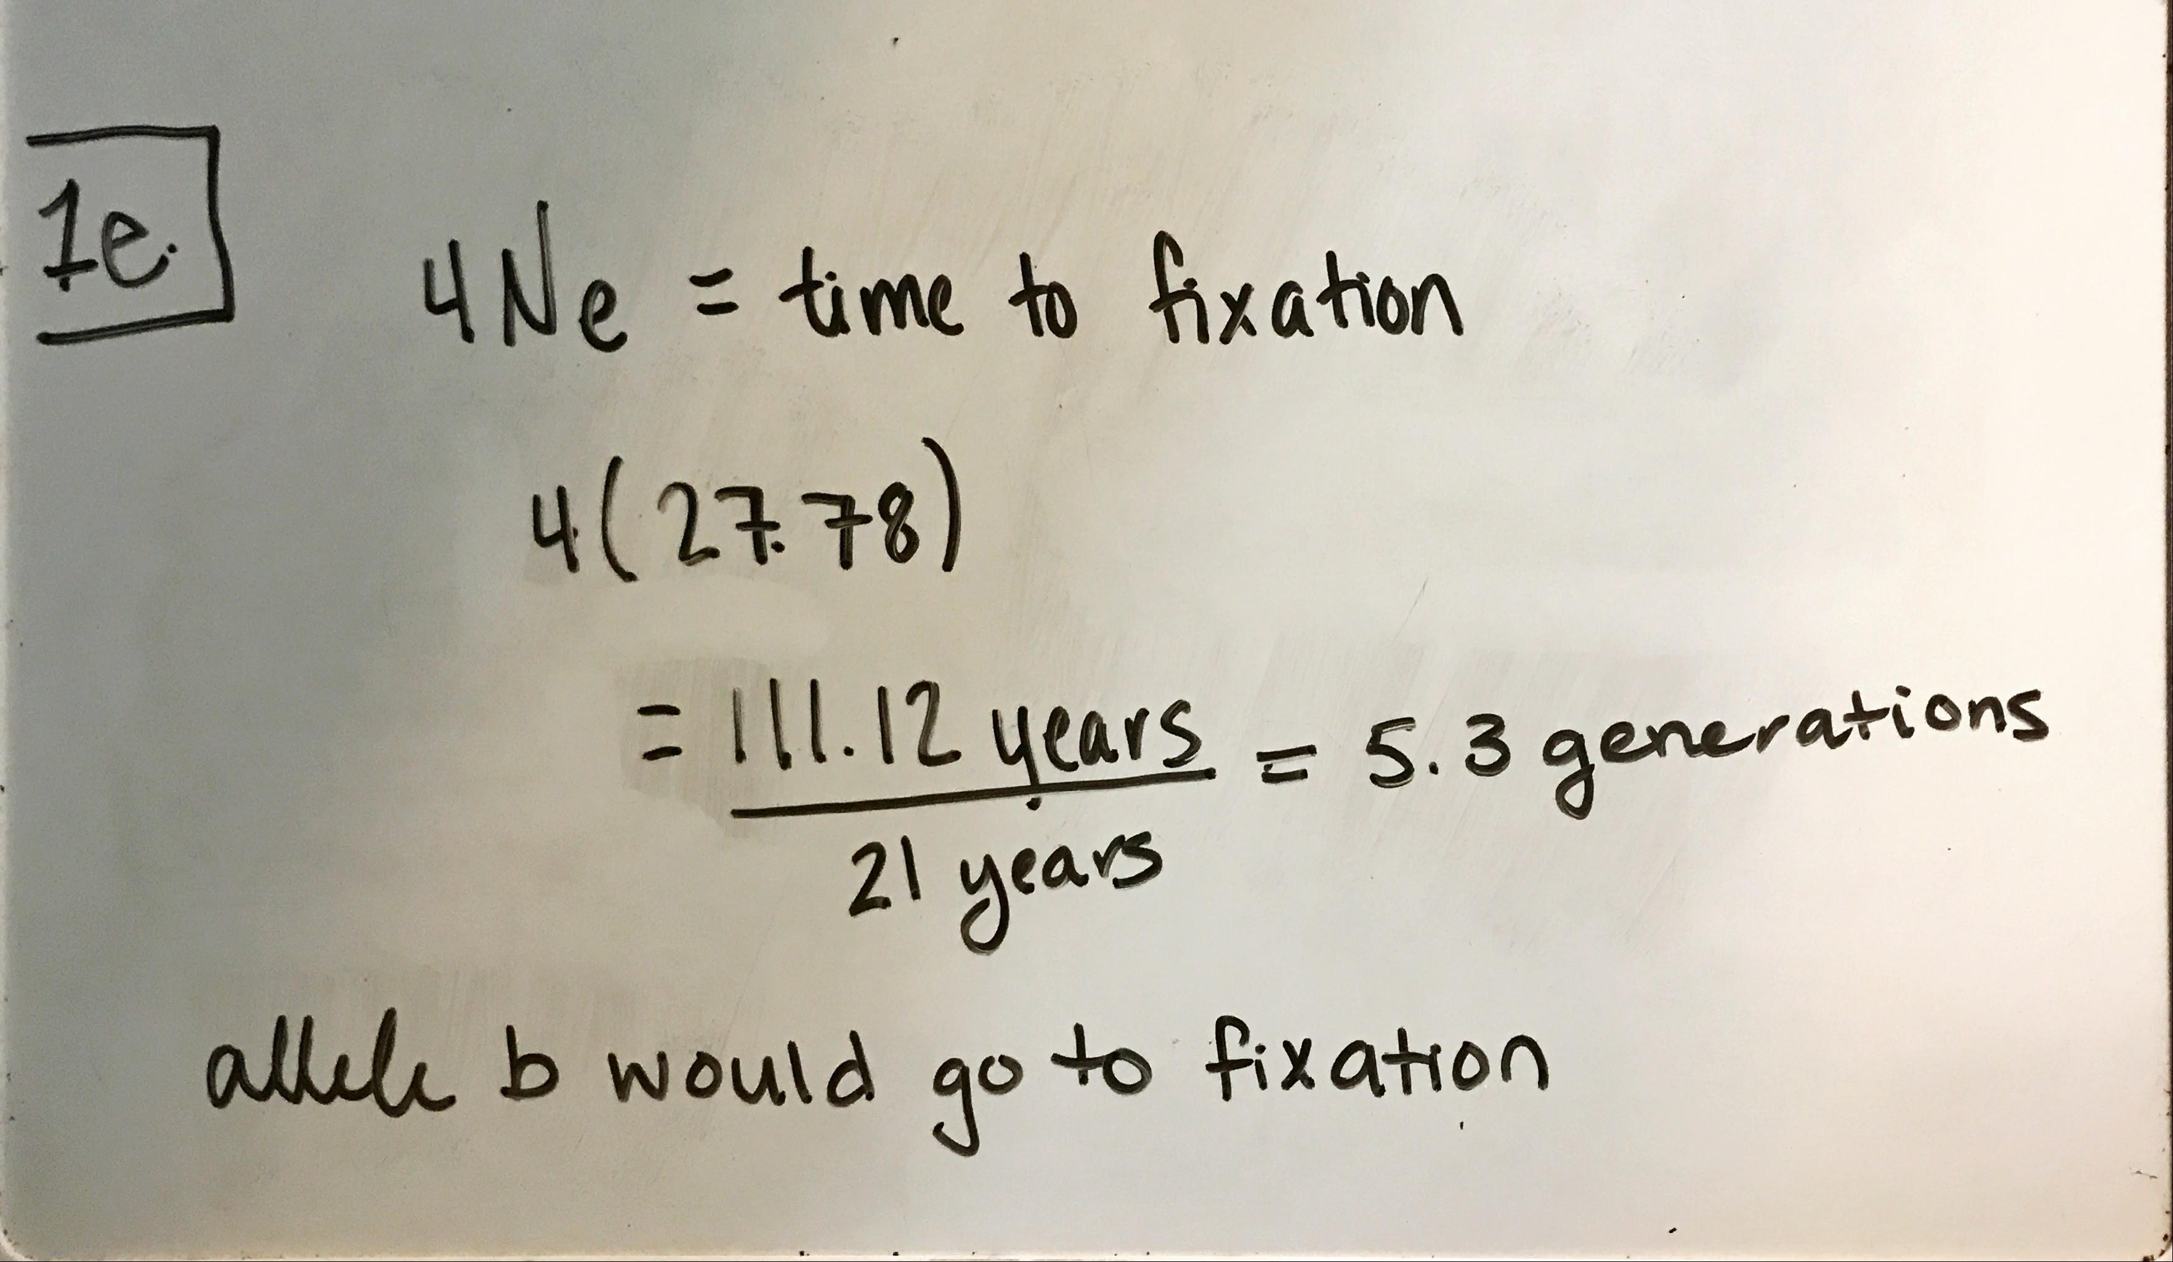

Allele b is what’s barely hanging in the population of 177 and has a fitness of 0 when homozygous, so I figure within 5.3 generations it has the best chances to fixation and would be the allele to probably disappear from the population.

2. The proportions of mutations differ between the fitness peaks because like the paper states, mutation is not always the best. The largest portion of genes in a population are harmful and eventually outnumber beneficial genes, showing the gradual increase in fitness but the drop in beneficial mutation rates. Organisms in new environments will most likely experience a lower fitness and increase the chances of a mutation, which in turn increases the chances that a beneficial mutation can arise. So, C is perfectly adapted, and thus any deviation from this perfect fit will be harmful.

3a. Based on the graph, we see a positive correlation between width and heterozygosity. But what links heterozygosity to fitness, is energy. “Growth and reproduction require energy”, so we know that the bigger the ring, the more energy the tree had. The more energy it had, the more it was able to put towards reproduction. And fitness is just the ability to reproduce. So, higher the heterozygosity, the higher the fitness.

3b. We know that inbreeding causes less genetic diversity and a decreased effective population size. So, we end up with less heterozygosity (more heterozygosity) and tree width. And earlier in 3a, as explained if we see a decrease in heterozygosity or fitness, we’ll see a decrease in tree ring width.

3c. To follow the trees in the model, heterozygosity leads to an increase in tree width. By looking at the graph, we know that between two populations the fluctuating one would consist of more heterozygotes while the stable population of homozygotes. So, in turn we know that with increased heterozygosity leads to an increase in trunk width.

3d. There’s a chance to test for a confounding variable between the correlation of average tree width and heterozygosity. Rainfall seems to have opposite effects on ring growth and reproduction. So, I would want to test that rainfall might or might not have a confounding effect on heterozygosity by hypothesizing that an increase in heterozygosity is found with an increase in rainfall. If it came back with no relationship, then it would help support that heterozygosity and average tree width are dependent on one another without other confounding variables.

4. We know they combined the two populations of wild arugula to create a new generation coming from different trichome counts. The added genetic variation to this problem, creates plants that still look like the parent but contain genes from both. How the treatment responds to a “stressor” signal (jasmonic acid), depends on its genes and what they have received.

5a. Fst is a measure of variation between populations, so to see a difference between the subpopulation and total we need the variables with the highest variables. So, we want to choose the variables like mixed-mating, non-woody, small insects, gravity, and tropics to increase our chances for speciation because they show the greatest variance, and allow for a likely hood of creating that distinct new species as compared to the total.

5b. So, temperate forests have the lowest Fst value, meaning the variance between subpopulations to the total is close to the same (increased homozygosity). My hypothesis is that temperate forest have less variance (less heterozygosity) than regions like the tropics because of wind patterns. Temperate forests are found on mainland, and may not be close to the coast, so less wind = less ability to disperse seeds long distances. Whereas, tropic areas are mostly on the coasts or islands where wind from the ocean is constantly dispersing seeds. So, heterozygosity and wind speed over a year can be measured and compared between temperate and tropic areas.

5c&d. Looking at these events at the same point in time, pollination allows for a greater creation of genetic variation as the combination of parent plants allows for the recombination of two haploid cells. While, seeds dispersal has the chance to fail to survive and grow and depends on where it lands. We would be looking for a low Fst value, as they still have remnants of ancient prokaryote DNA and each of today’s subpopulation would be similar to that of the total population as they have not changed over the course of several thousand years.

6a. So, after looking at a couple different papers on genome size and mutation rate, it turns out RNA and DNA have very similar mutation rates (1.6 E-06 and 1.1 E-06 respectively). This is used in Drake’s Rule, where the mutation rate per genome per copying strand is roughly constant across DNA organisms and shows an inverse relationship. Other papers such as Bradwell et al. support that viruses follow this similar correlation. Lastly, Bourguignon et al. found that smaller genomes often lack repair genes, which supports larger viruses having correcting mechanisms.

Bourguignon T, Kinjo Y, Villa-Martín P, Coleman NV, Tang Q, Arab DA, Wang Z, Tokuda G, Hongoh Y, Ohkuma M, et al. 2020. Increased Mutation Rate Is Linked to Genome Reduction in Prokaryotes. Curr Biol. 30(19):3848-3855.e4. doi:10.1016/j.cub.2020.07.034.

Bradwell K, Combe M, Domingo-Calap P, Sanjuán R. 2013. Correlation Between Mutation Rate and Genome Size in Riboviruses: Mutation Rate of Bacteriophage Qβ. Genetics. 195(1):243–251. doi:10.1534/genetics.113.154963.

Sanjuán R, Nebot MR, Chirico N, Mansky LM, Belshaw R. 2010. Viral Mutation Rates. Journal of Virology. 84(19):9733–9748. doi:10.1128/JVI.00694-10.

6b. It would be hard to provide evidence that selection is at play here, that these viruses are mutating within this population. Instead, I can see that from the original strand drift is at play here, starting at 100% frequency and then going to extinction. But I do not think selection can be ruled out completely as selection pushes drift further and further. So, while the graph looks like drift, selection is probably always working underneath but is hard to quantify.

6c. Selection because as it states in the question that it is a “variant of concern”, it is selecting to make more of itself and might become more virulent along the way. Then, mutation as there are 17 copies that have come about that are not found in the nearest relative strain. Lastly, drift may also come into effect here because of the changes in the different strains being pushed (selection) to see the exponential growth in the graph. It doesn’t state they are more fit, only that they change their frequency in the population.

6d. The larger the number of cases, the more viruses that exist in a population, which increases the chance for mutation to happen. If the virus only infected 12 people, there is less of a chance for it to mutate before it goes extinct. However, with 1 million people chances are it will persist for a longer amount of time and have better chances to mutate and stay in the population.

7. Linkage disequilibrium is the nonrandom assortment of alleles and is affected by two things: selection and drift. LD is like taking a small sample from a large population and looking at it as one. Drift in a small population is sped up and is constantly creating new combinations during recombination (a random event possibly effecting a nonrandom event). While selection maintains LD and increases certain haplotypes within that population which decreases genetic variance, drift’s recombination is in a race to lower LD.